**PROJECT REPORT**

**TITLE NAME: Plugging into the Future: An Exploration of Electricity Consumption Patterns**

**1.INTRODUCTION**

**1.1 Overview**

Power development in India was first started in 1897 in Darjeeling Since 1990, India has been one of the faster growing technology to produce new electricity generation.

India’s central government and state government jointly regulate electricity sector in India along with some privately-owned companies.

1.2 Purpose  
 The main purpose to consume electricity to save resources and for our future generation.

Another important thing is the lower consumption of electricity cause lower tax which turns into higher per capita income.

# **2.PROBLEM DEFINITION**

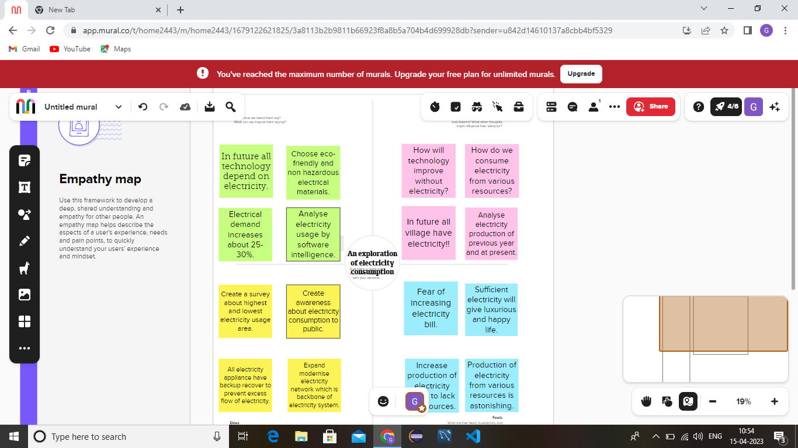

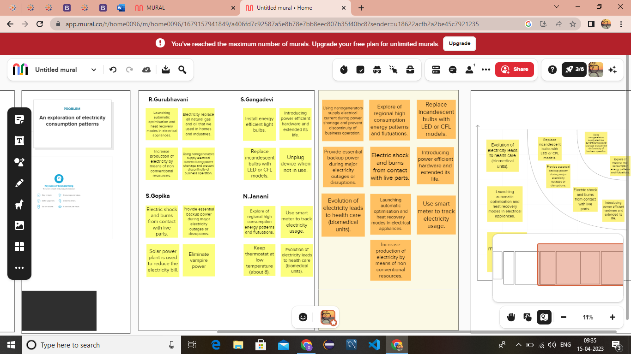

**3.RESULT**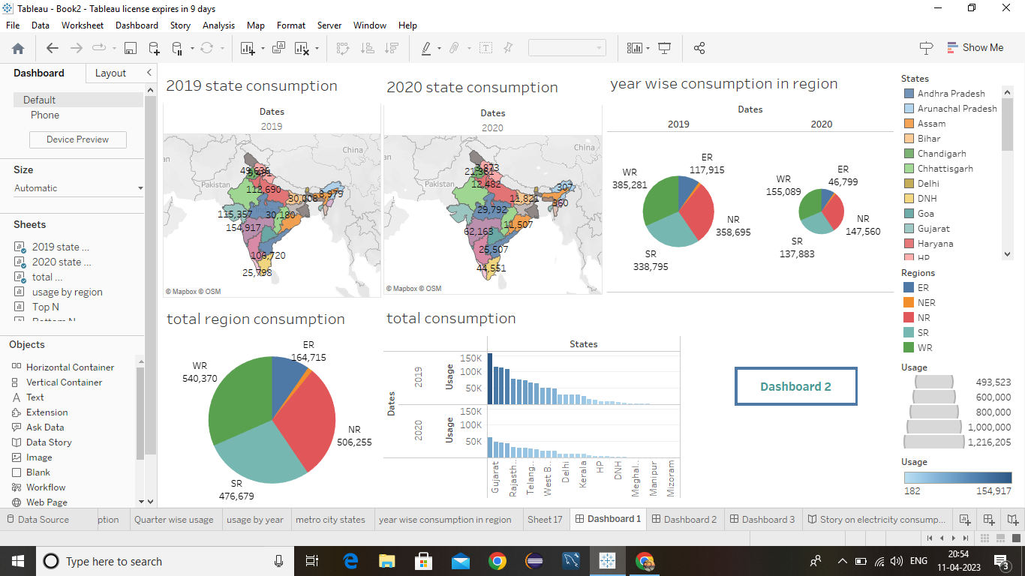

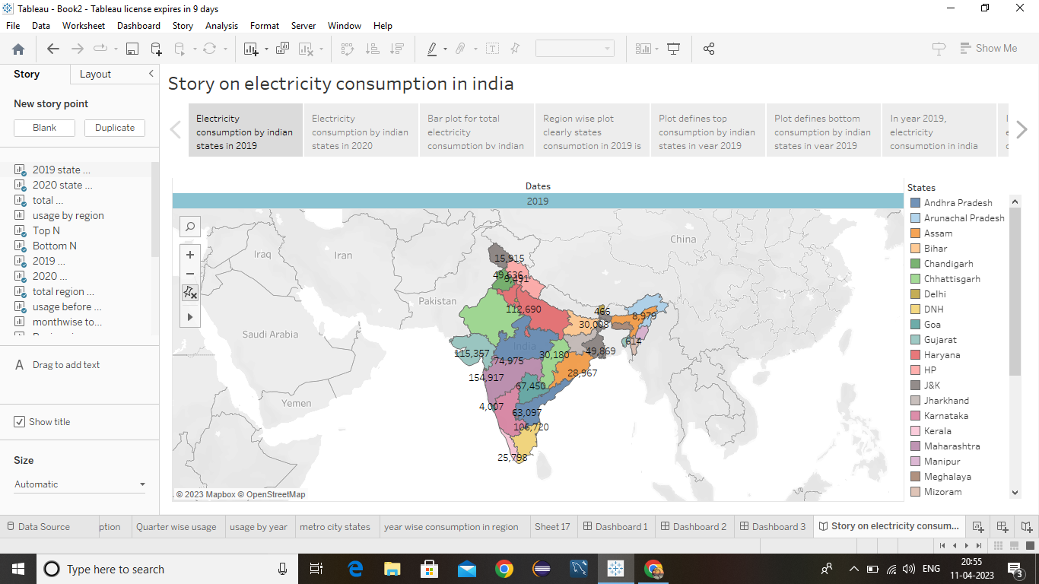

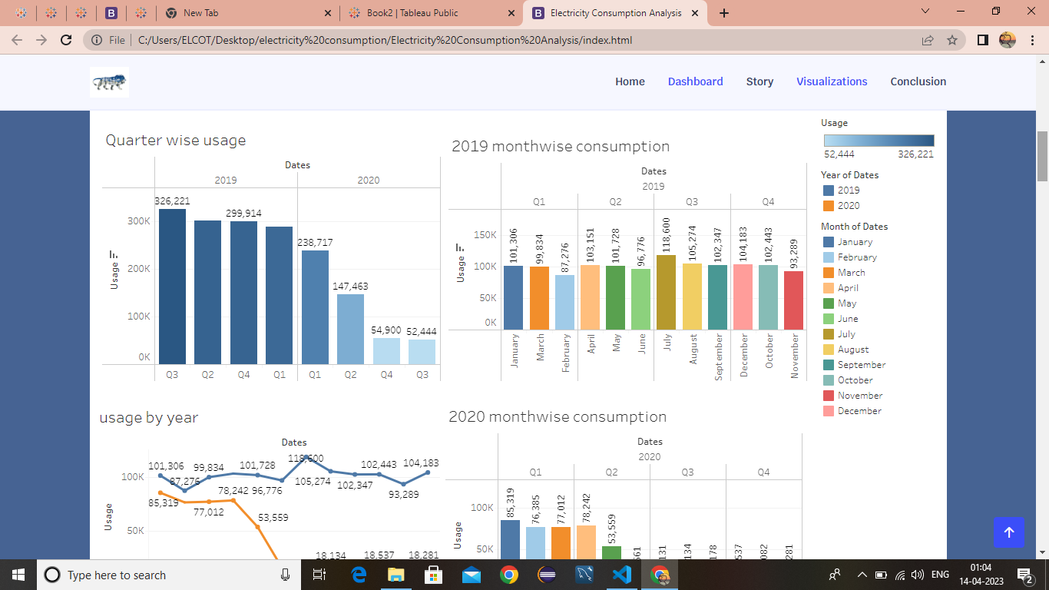

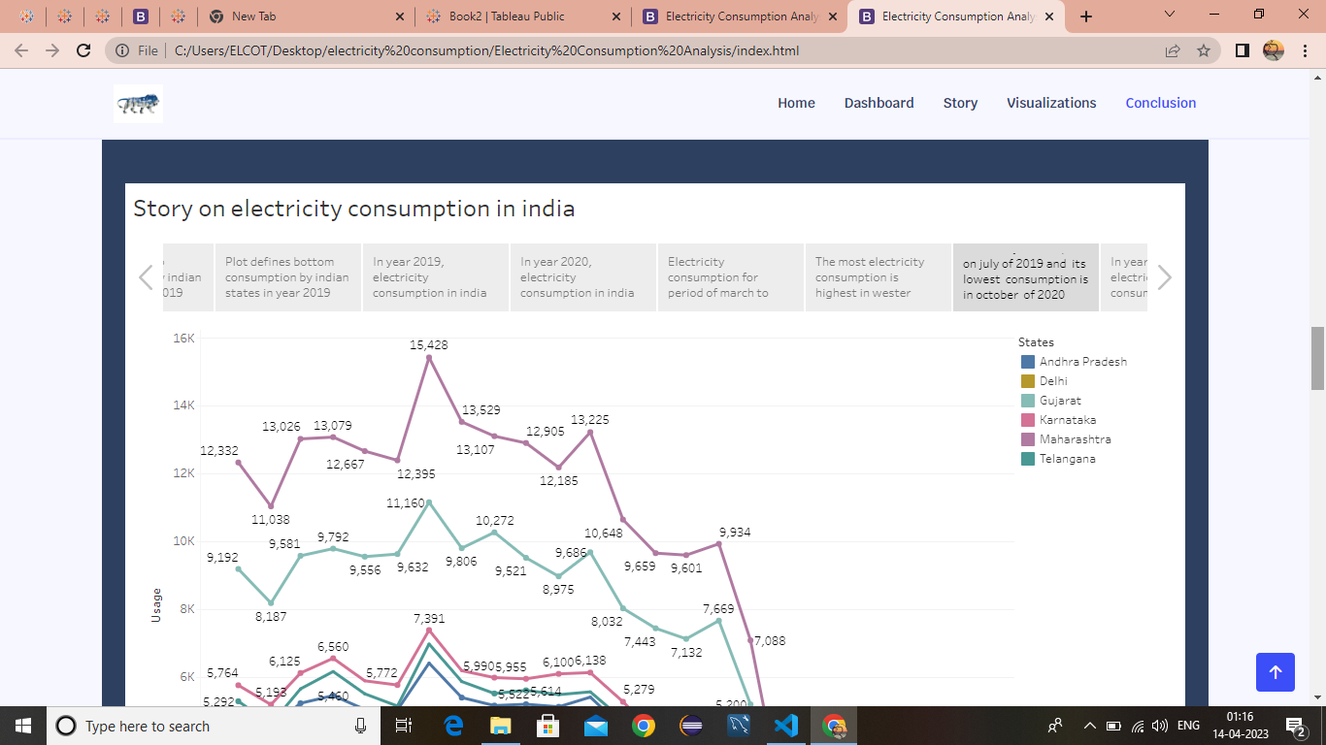

**4.ADVANTAGES AND DISADVANTAGES**

4.1 Advantages

•Alternate form of energy is renewable.

•Hydroelectric station are inexpensive to operate.

•Renewable sources energy is cheap compare to other and it is has lower maintenance.

**4.2 Disadvantages**

•Causes an electricity shock (which reduce your physical energy)and lasting mental damage.

•Alternate form electricity causes radiation which turns into health.

•Global warming.

•Sometimes messes up wildlife.

•Change in river stream quality.

**5.APPLICATIONS**

•Public acceptability, cost and nuclear energy in the future.

•Energy policy and planning electricity for each sectors such as agricultural and modernization field.

•A sustainable solution for future electricity.

•Electricity consumption ideas changes sustainable energy technology and chemical processes.

**6.CONCLUSION**

Our life go back to the primitive age without electricity.The energy primer is limited and will finish.PLN(the state owned electricity company perusahaan listrik negara)avoids to use fuel consumption and shift to renewable energy.All customers must know about this crisis and save electricity every time.

**7.FUTURE SCOPE**

•Many industrial process and transportation technology rely on their own combustion engine to run however technology improve, it is increasingly possible for this need onsite fossil fuel powered combustion engine to be replaced with electricity know as electricity.

•Another process similar to electricity is home heating previously the domain of natural gas, propene, disel, coal are transferred to improve technology such as air source and heat pumbs that helps to heat your home rather than burning fuel.

•It provides clean and safe light throughout the day.

**BY**

**R. GURUBHAVANI**

**S. GANGADEVI**

**S. GOPIKA**

**N. JANANI**